**Power BI Project**

**Overview of Power BI Project**

**Human Resources Attrition Project**

Page 1 -Company Overview

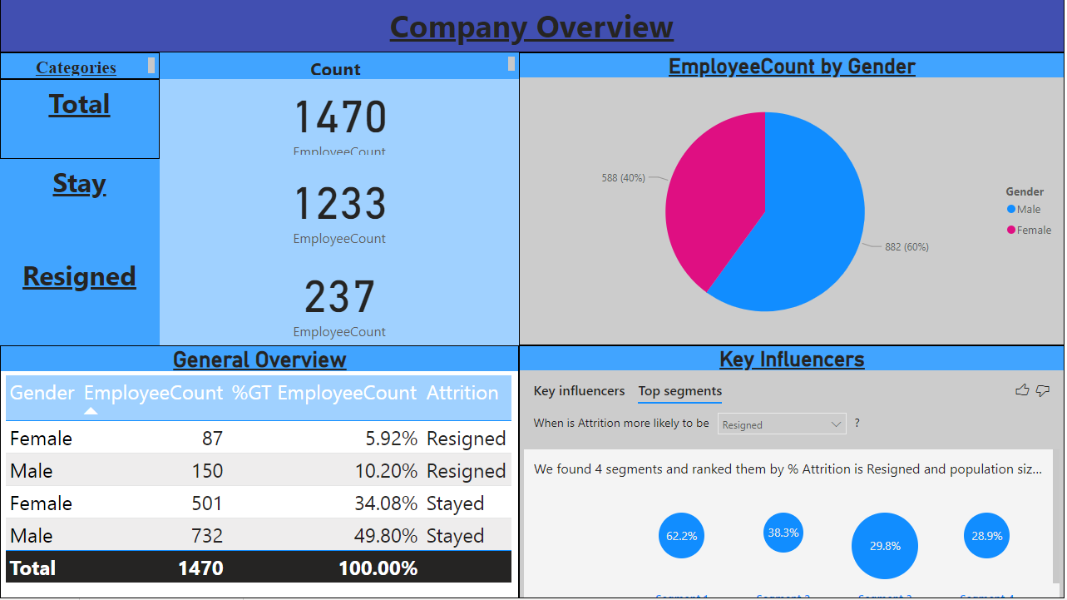

The Company overview page let us know how many employees that have stayed or resigned and the total number of employees in general. On the right-hand side, it graphically shows the male and female employee on total number of employees. All the function used are interactive.

There is a table which show the gender with their attrition status and provide an employee count and its percentage.

Finally, there are key influencer’s function. They are to explore the initial factors that caused the attrition rate.

Page 2 – Demographic Overview

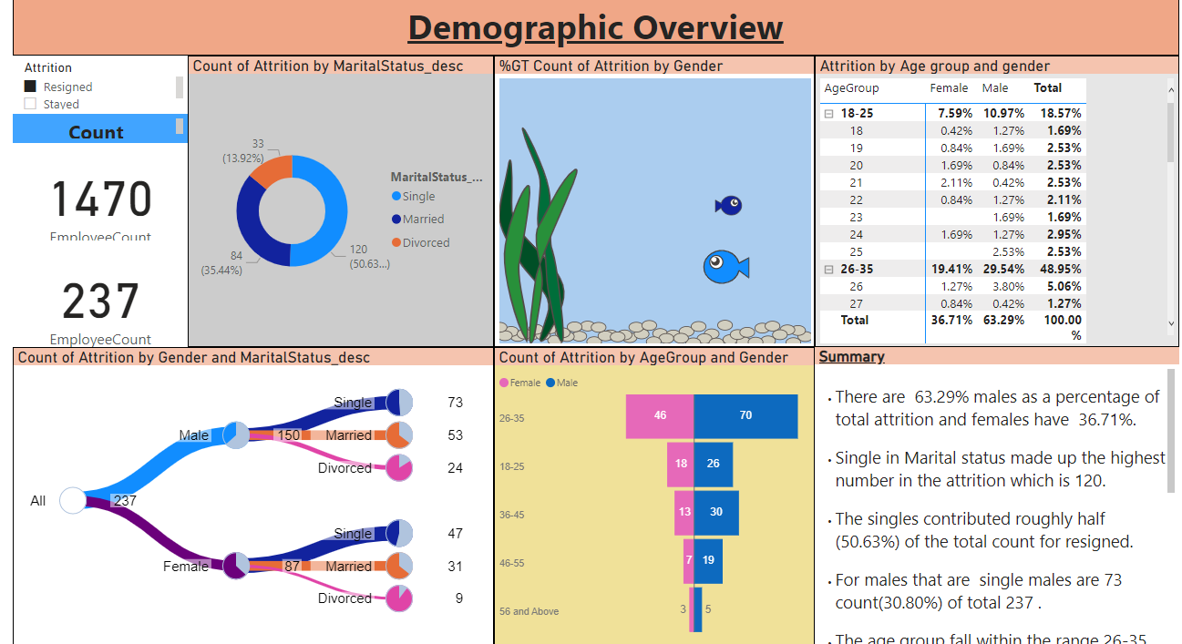

In This page, we will be exploring the demographic in the company. There is a slicer added at the top left-hand corner. This helps the user easily to know how many are resigned into different categories and those that had stayed.

The Percentage of attrition by gender will be using the enlighten Aquarium for the display effects. The Size of the fish is represented with the percentage of the count by gender.

The Marital Status is another factor we need to investigate, whether those that are married are likely to stay or resigned. There is a pie chart tree which show more subcategories in relation to main categories through branches.

The Tornado chart is used as it is best use to do a comparison with the 2 factors. For this case, it is well used to display male and female and its count of employee in each age group.

The Matrix Table will be a great help as it can break down the numbers in male and female given each age.

Finally, there is a summary which is my observation of the demographic in the company.

Page 3 – Education Overview

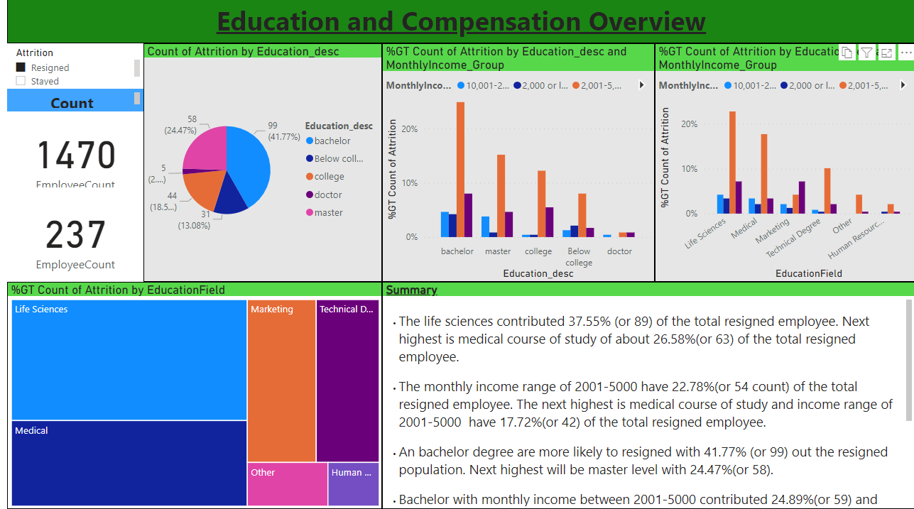

This page, we will be doing the employee’s education. It is to find out this factor whether it affect the attrition rate based on people education or education with another factor. Firstly, we will use a pie chart.

The Clustered column chart is best used for grouping subcategories from the main categories. It displays well and with each education level, we will be able to see and compare it with different educational level. Then, there is another field which is the course that had graduated. With clustered Column chart, we can compare the attrition rate across the chart with different education field.

The Tree map is best use for quick glance which contribute the highest attrition by count. The size in the tree map is proportionately to their size.

Page 4 –Job Requirement and workload

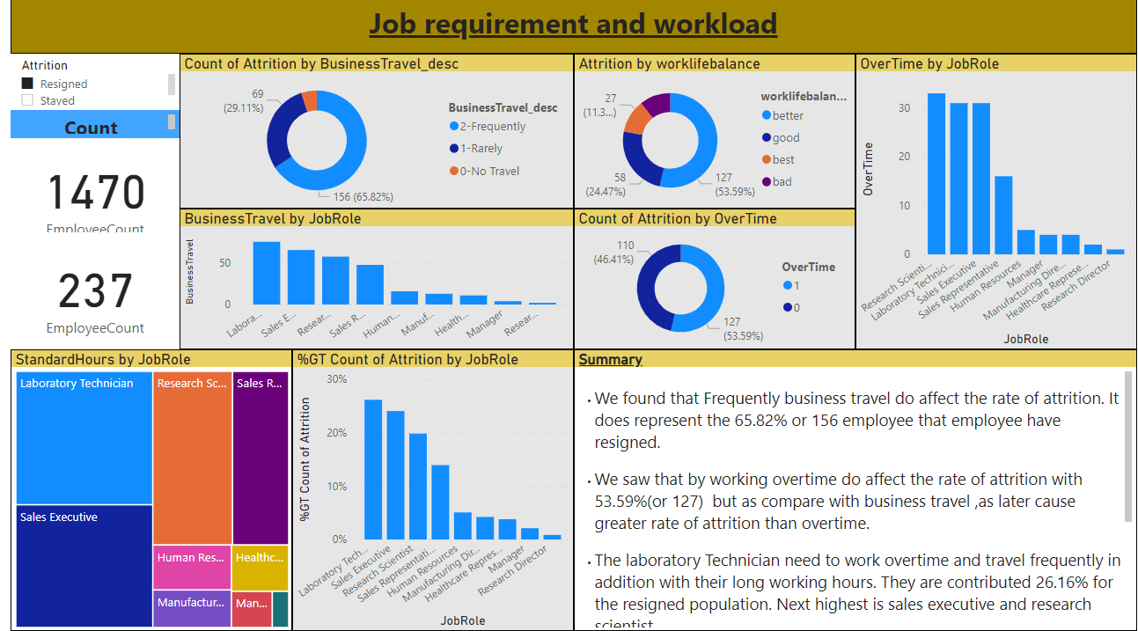

This page we will be concern with the job workload and requirement and to find out whether it will affect the attrition rate.

The donut chart is used to show the proportions of business travel data, with the size of each piece representing the proportion of each category. For both the work life balance and overtime factor, we will use the donut chart as well. It shows which area contribute the highest portion at a glance.

Treemap on the other hand display block by block and with the highest contributing factor, it will be at the top left hand corner.

To find out which job role have the most frequently overtime and most business travel, we use the clustered column chart. It is easily to compare the factors across the chart. Finally, we need to know the count of attrition by job role and to finalise the two factors are contributing the attrition rate.

Page 5 – Employees matters

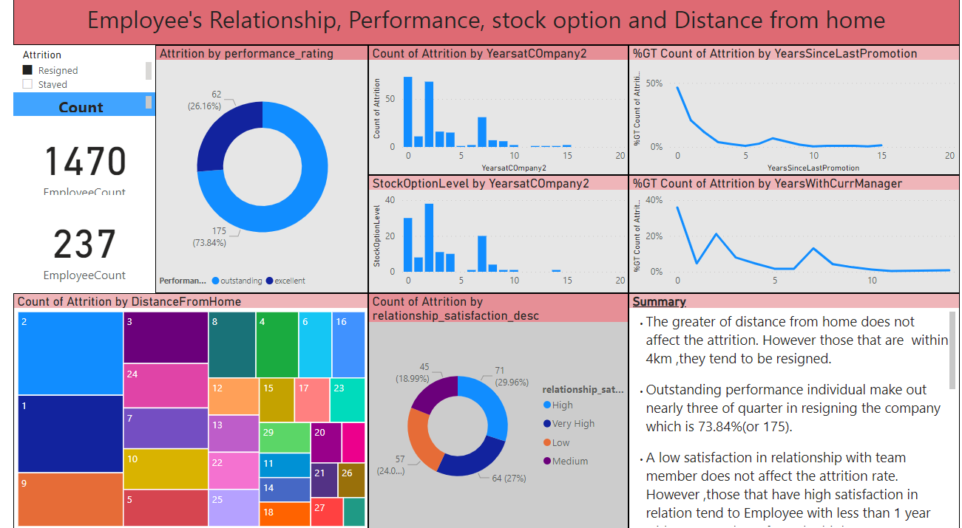

Finally, we will look into Employee matters.

The performance rating factor, we will find out using the donut chart of how many are outstanding and how many are excellent performance that contributing the most attrition rate.

The Tree map will be good to used for the distance from home to work. The Top left corner will show the highest attrition rate and there is a number at top left corner in each boxes display the distance from home.

The Relationship satisfaction between the employee and their superior may have contribute to the attrition rate. For this part, we will use the donut chart for the display. Prior relationship ,The next similar will be the years with current manager and we use a line chart which is best illustrate over their working period.

Years in the company may also play an important role in contributing to the attrition rate. After the looking through the data, we can see data does not fluctuate much which we will be using the clustered column chart. The related to years in the company is the stock option. We need find out the stock option available to the employee as well and can use interactive to another chart.

The Attrition rate by promotion in years, we can use line chart. As we can see there is a drastic change over a period, we can use the line chart to illustrate.

The interactive part for the Employee matters

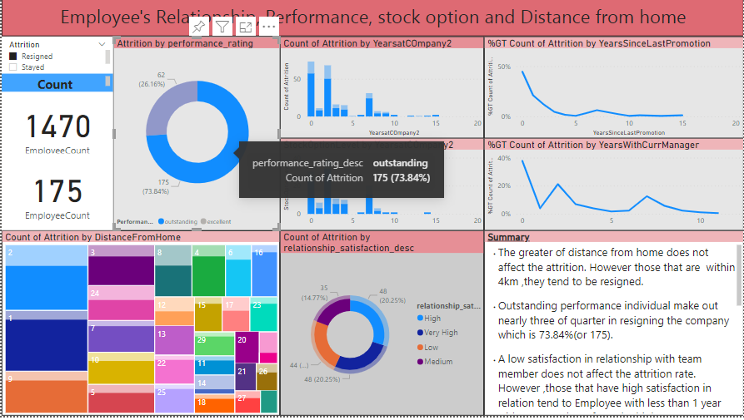

What make the power bI so powerful? It has the ability to organise, compare, interactive and display the data that we need. For the first chart, we know the outstanding performance is the main contributing factor and we need to know the count for other aspect given outstanding performance individual.

Page 6 -Summary

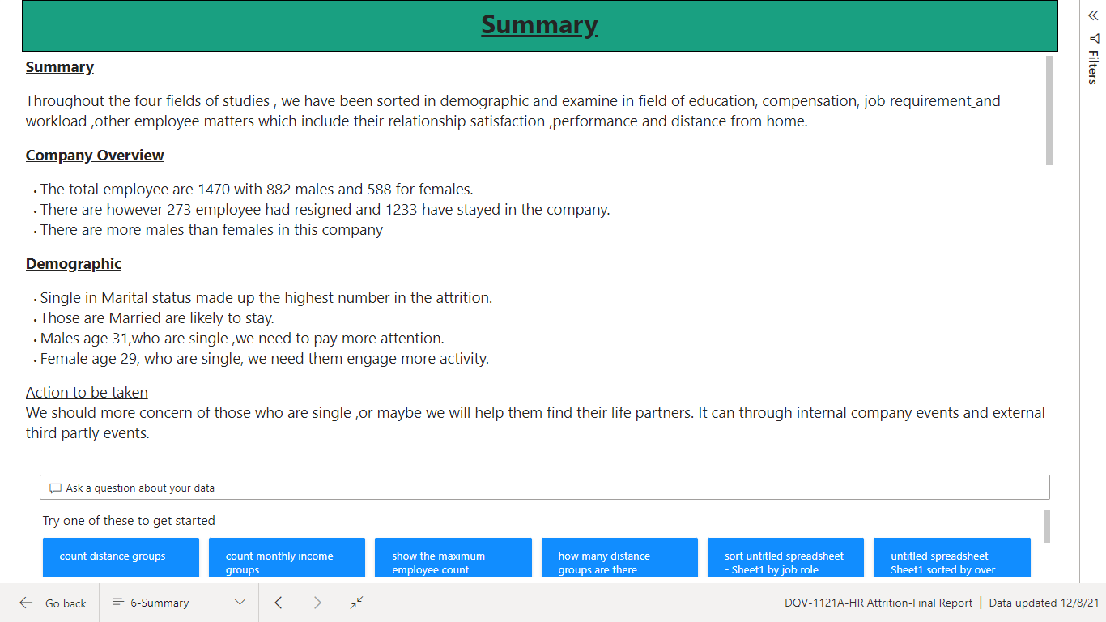

This is the summary page.

In this page, I will be using text box for all the summaries. First, I will highlight all the finding and contribution factors to attrition rate in each page. There will be a suggested action or measure to be taken after our finding.

Then, we will conclude our priority and concern and monitor it closely Proper action is to be taken to avoid losing of talents to other company.

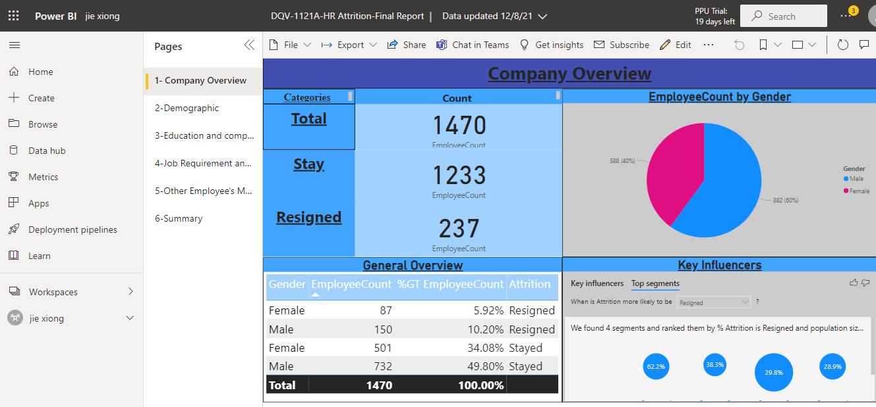

This Project have done and completed solely by Jie Xiong Chiang.